APPLICATION FORM
International & Interdisciplinary CEEPUS Summer School 18-27.09.2017
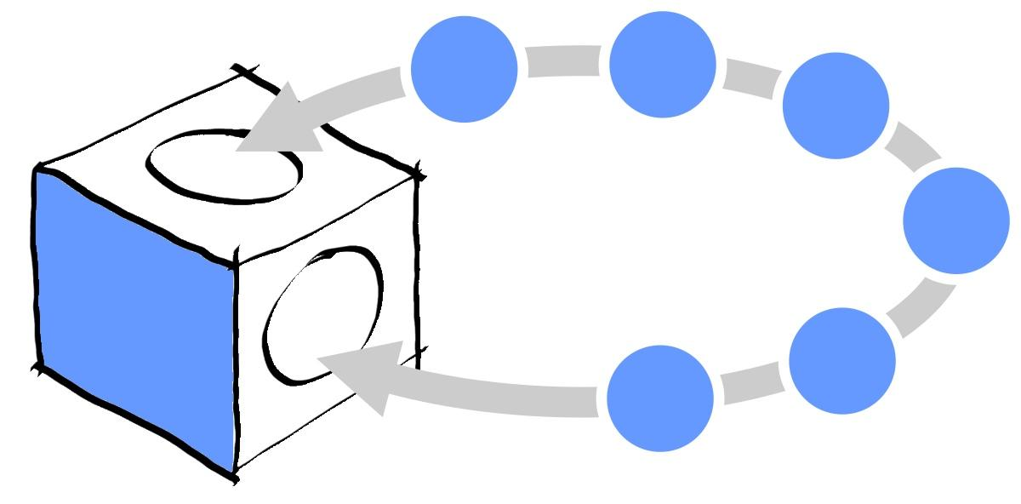
NTERDISCIPLINARY APPROACH IN SHAPING SUSTAINABLE PUBLIC SPACE SUMMER SCHOOL, Gliwice, Poland,
18-27.09.2017
- Name and Surname of PhD student:

- Name of University/Department:

Address:

- Email of PhD student:

Please tick [x] the name of summer school you are interested in participation:
Human Factors Engineering & Ergonomics | [ ]
Design for sustainable public space | [ ]
Crisis management in the urban space | [ ]
Intelligent functional materials of the future | [ ]
Smart-house: Energy systems and ICT for intelligent building in the Smart City | [ ]
Innovative materials and technologies in structural Engineering | [ ]

come and work with over 60 PhD students from various EU countries work with colleagues from 6 different specialties experiment and enjoy Silesian University of Technology and more try CEEPUS Central European Exchange Program for University Studies

